**Workforce Data Analytics using SQL**

**The challenges**

**Task 1**

**Task 1.1**

In your company there hasn't been a database table with all the employee information yet.

You need to set up the table called employees in the following way:



There should be NOT NULL constraints for the following columns:

first_name,

last_name ,

job_position,

start_date DATE,

birth_date DATE

**Task 1.2**

Set up an additional table called departments in the following way:



Additionally no column should allow nulls.

**Task 2**

Alter the employees table in the following way:

- Set the column department_id to not null.

- Add a default value of CURRENT_DATE to the column start_date.

- Add the column end_date with an appropriate data type (one that you think makes sense).

- Add a constraint called birth_check that doesn't allow birth dates that are in the future.

- Rename the column job_position to position_title.

**Task 3**

**Task 3.1**

Insert the following values into the employees table.

There will be most likely an error when you try to insert the values.

So, try to insert the values and then fix the error.

Columns:

1. (emp_id,first_name,last_name,position_title,salary,start_date,birth_date,store_id,department_id,manager_id,end_date)

Values:

1. (1,'Morrie','Conaboy','CTO',21268.94,'2005-04-30','1983-07-10',1,1,NULL,NULL),
2. (2,'Miller','McQuarter','Head of BI',14614.00,'2019-07-23','1978-11-09',1,1,1,NULL),
3. (3,'Christalle','McKenny','Head of Sales',12587.00,'1999-02-05','1973-01-09',2,3,1,NULL),
4. (4,'Sumner','Seares','SQL Analyst',9515.00,'2006-05-31','1976-08-03',2,1,6,NULL),
5. (5,'Romain','Hacard','BI Consultant',7107.00,'2012-09-24','1984-07-14',1,1,6,NULL),
6. (6,'Ely','Luscombe','Team Lead Analytics',12564.00,'2002-06-12','1974-08-01',1,1,2,NULL),
7. (7,'Clywd','Filyashin','Senior SQL Analyst',10510.00,'2010-04-05','1989-07-23',2,1,2,NULL),
8. (8,'Christopher','Blague','SQL Analyst',9428.00,'2007-09-30','1990-12-07',2,2,6,NULL),
9. (9,'Roddie','Izen','Software Engineer',4937.00,'2019-03-22','2008-08-30',1,4,6,NULL),
10. (10,'Ammamaria','Izhak','Customer Support',2355.00,'2005-03-17','1974-07-27',2,5,3,2013-04-14),
11. (11,'Carlyn','Stripp','Customer Support',3060.00,'2013-09-06','1981-09-05',1,5,3,NULL),
12. (12,'Reuben','McRorie','Software Engineer',7119.00,'1995-12-31','1958-08-15',1,5,6,NULL),
13. (13,'Gates','Raison','Marketing Specialist',3910.00,'2013-07-18','1986-06-24',1,3,3,NULL),
14. (14,'Jordanna','Raitt','Marketing Specialist',5844.00,'2011-10-23','1993-03-16',2,3,3,NULL),
15. (15,'Guendolen','Motton','BI Consultant',8330.00,'2011-01-10','1980-10-22',2,3,6,NULL),
16. (16,'Doria','Turbat','Senior SQL Analyst',9278.00,'2010-08-15','1983-01-11',1,1,6,NULL),
17. (17,'Cort','Bewlie','Project Manager',5463.00,'2013-05-26','1986-10-05',1,5,3,NULL),
18. (18,'Margarita','Eaden','SQL Analyst',5977.00,'2014-09-24','1978-10-08',2,1,6,2020-03-16),
19. (19,'Hetty','Kingaby','SQL Analyst',7541.00,'2009-08-17','1999-04-25',1,2,6,'NULL'),
20. (20,'Lief','Robardley','SQL Analyst',8981.00,'2002-10-23','1971-01-25',2,3,6,2016-07-01),
21. (21,'Zaneta','Carlozzi','Working Student',1525.00,'2006-08-29','1995-04-16',1,3,6,2012-02-19),
22. (22,'Giana','Matz','Working Student',1036.00,'2016-03-18','1987-09-25',1,3,6,NULL),
23. (23,'Hamil','Evershed','Web Developper',3088.00,'2022-02-03','2012-03-30',1,4,2,NULL),
24. (24,'Lowe','Diamant','Web Developper',6418.00,'2018-12-31','2002-09-07',1,4,2,NULL),
25. (25,'Jack','Franklin','SQL Analyst',6771.00,'2013-05-18','2005-10-04',1,2,2,NULL),
26. (26,'Jessica','Brown','SQL Analyst',8566.00,'2003-10-23','1965-01-29',1,1,2,NULL)

**Task 3.2**

Insert the following values into the departments table.

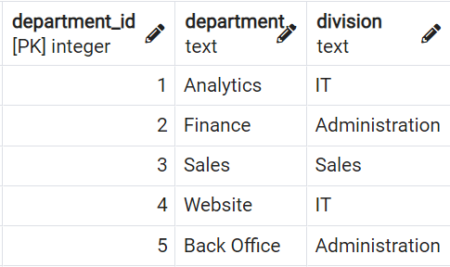

**Task 4**

**Task 4.1**

Jack Franklin gets promoted to 'Senior SQL Analyst' and the salary raises to 7200.

Update the values accordingly.

**Task 4.2**

The responsible people decided to rename the position_title Customer Support to Customer Specialist.

Update the values accordingly.

**Task 4.3**

All SQL Analysts including Senior SQL Analysts get a raise of 6%.

Upate the salaries accordingly.

**Task 4.4**

Question:

What is the average salary of a SQL Analyst in the company (excluding Senior SQL Analyst)?

**Task 5**

**Task 5.1**

Write a query that adds a column called manager that contains  first_name and last_name (in one column) in the data output.

Secondly, add a column called is_active with 'false' if the employee has left the company already, otherwise the value is 'true'.

**Task 5.2**

Create a view called v_employees_info from that previous query.

**Task 6**

Write a query that returns the average salaries for each positions with appropriate roundings.

Question:

What is the average salary for a Software Engineer in the company.

**Task 7**

Write a query that returns the average salaries per division.

Question:

What is the average salary in the Sales department?

**Task 8**

**Task 8.1**

Write a query that returns the following:

emp_id,

first_name,

last_name,

position_title,

salary

and a column that returns the average salary for every position_title.

Order the results by the emp_id.

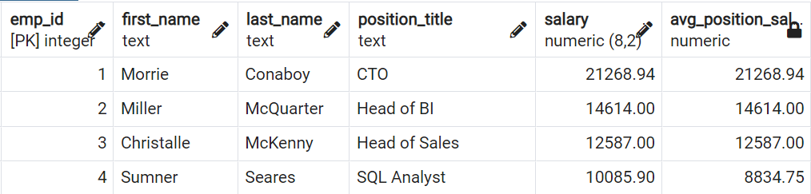

**Task 8.2**

How many people earn less than there avg_position_salary?

Write a query that answers that question.

Ideally, the output just shows that number directly.

**Task 9:**

Difficulty: Advanced

Write a query that returns a running total of the salary development by the start_date.

In your calculation, you can assume their salary has not changed over time, and you can disregard the fact that people have left the company (write the query as if they were still working for the company).

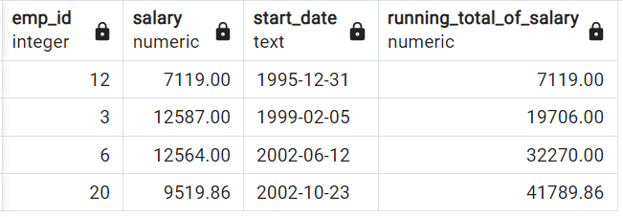

Question:

What was the total salary after 2018-12-31?

**Task 10:**

Create the same running total but now also consider the fact that people were leaving the company.

Question:

What was the total salary after 2018-12-31?

**Task 11**

**Task 11.1**

Write a query that outputs only the top earner per position_title including first_name and position_title and their salary.

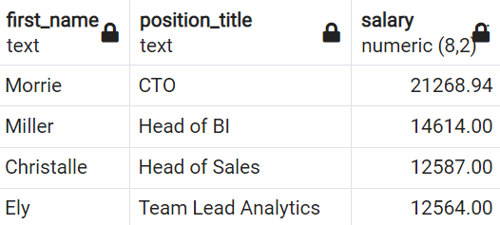

Question:

What is the top earner with the position_title SQL Analyst?

**Task 11.2**

Add also the average salary per position_title.

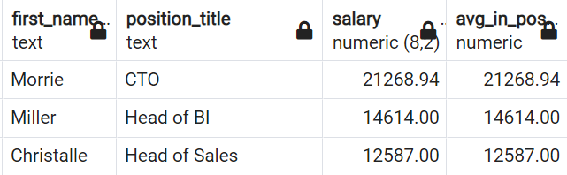

**Task 11.3**

Remove those employees from the output of the previous query that has the same salary as the average of their position_title.

These are the people that are the only ones with their position_title.

**Task 12**

Write a query that returns all meaningful aggregations of

- sum of salary,

- number of employees,

- average salary

grouped by all meaningful combinations of

- division,

- department,

- position_title.

Consider the levels of hierarchies in a meaningful way.

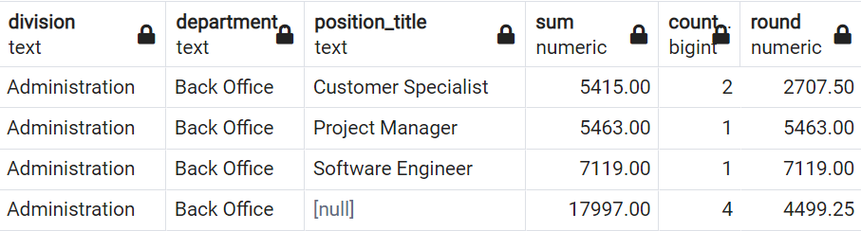

**Task 13**

Write a query that returns all employees (emp_id) including their position_title, department, their salary, and the rank of that salary partitioned by department.

The highest salary per division should have rank 1.

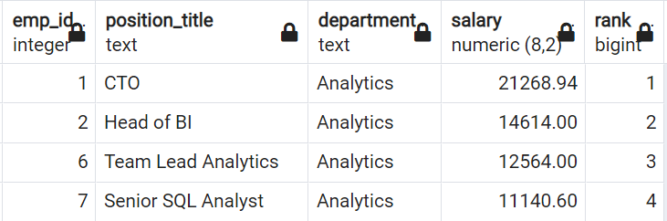

Question:

Which employee (emp_id) is in rank 7 in the department Analytics?

**Task 14**

Write a query that returns only the top earner of each department including

their emp_id, position_title, department, and their salary.

Question:

Which employee (emp_id) is the top earner in the department Finance?